GitHub Best Practices  
-------------------------------------------------------------------

Whenever we are working on a Git we have to remember the below points

1. Don’t commit(save) your code in the middle of your work because the commit history will increase

Commit Your code once everything is ready

1. Test your code before commit
2. In Real Time we havei to save the commit message like this

Git commit –m ‘I update prod.yaml’ a meaningful message

1. To avoid the merge conflicts always communicate with the developers
2. Always raise pull request before merging don’t merge the code blindly
3. Find out no of created branches take the approval and delete the old branches that are not in use.
4. As a Devops engineer delete the old stashes

So far what we did is we pushed the code from

working area -2- Stagin area -2- Local Repository -2-Remote Repository.

Let’s do the reverse Now by using ‘Git Clone ‘ command

By Executing the command ‘git clone’ we can copy the github repository folder in to our Local computer without executing using git init command .

By executing the git clone command the we can directly download the github Remote repository code directly in to our local computer .git ignore file is directly get created in to our local computer

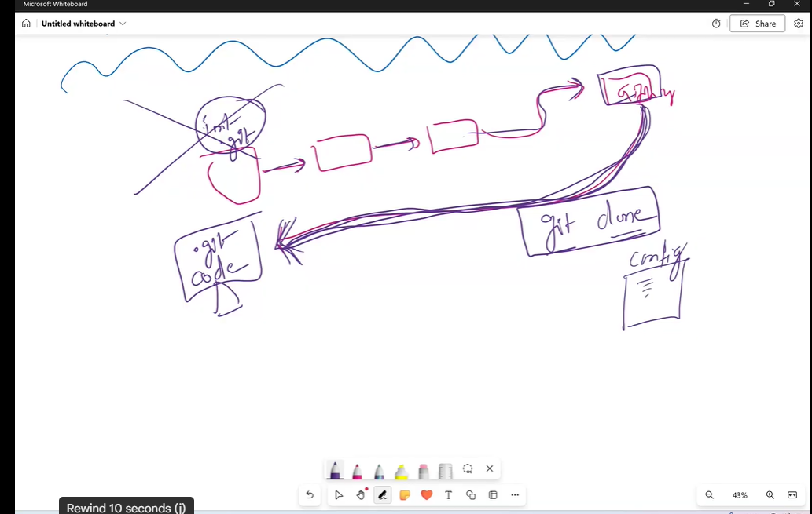

* So when do we execute this git clone command for suppose as a devops engineer we receive a request to make changes in the configuration file that is available in the Remote Github Repository.
* So first what we need to do after receiving the requirement from the team leader to make changes in the configuration file present in the github repository we need to download the Remote Github Folder in to our local computer by following the below steps

a) create a folder in the local computer for example Remote Github Folder

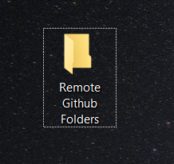

open the folder Remote Github Folder in git bash cli 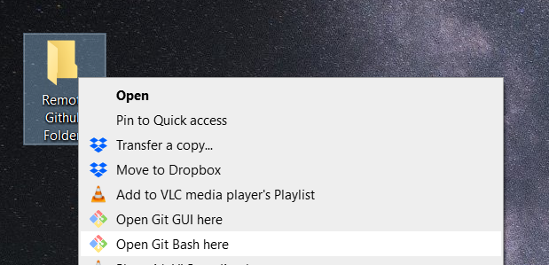

open the folder in git bash shown in the below image  
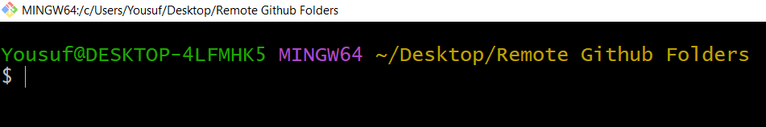

Now let’s copy and paste code available in the github repo in to our folder Remote github folder  
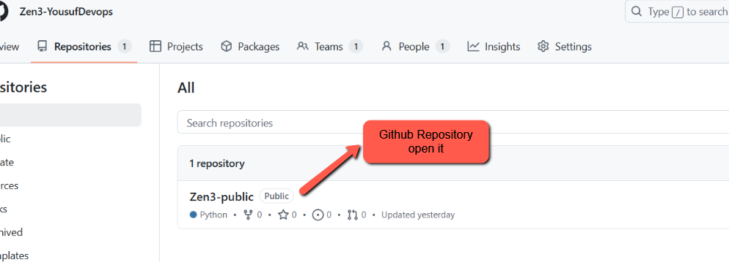

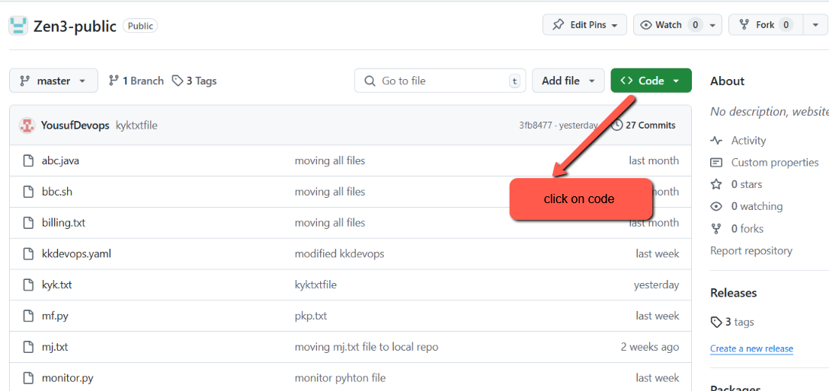

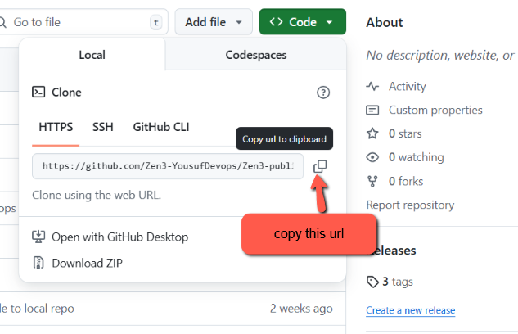

After copying the HTTPS URL go back to gitbash cli 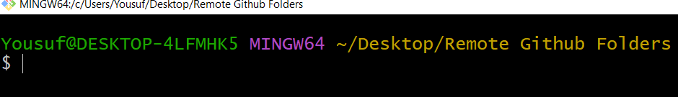

Execute the command git clone command with the copied https url shown in the below image

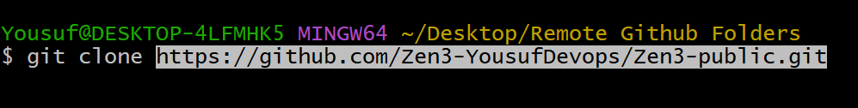

Press Enter

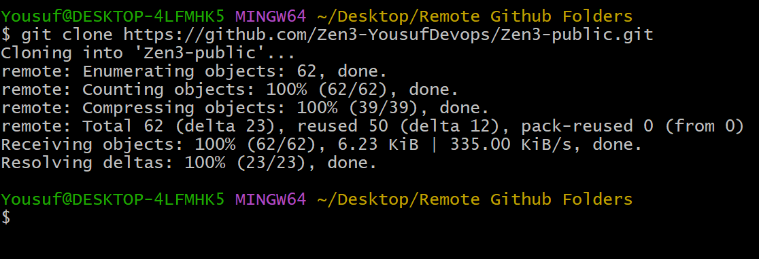

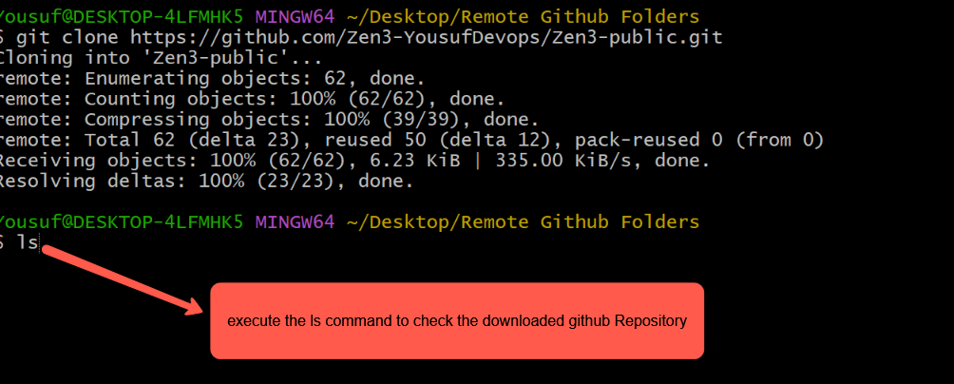

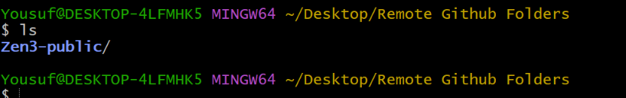

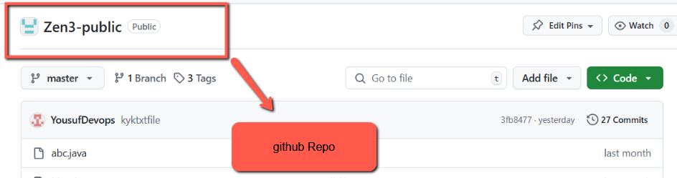

We have successfully cloneed the github repo(Zen3-public) in to our local computer

* Observe a point when we open the Zen3-public folder by default it will point to master

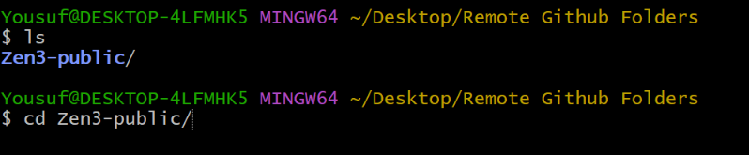

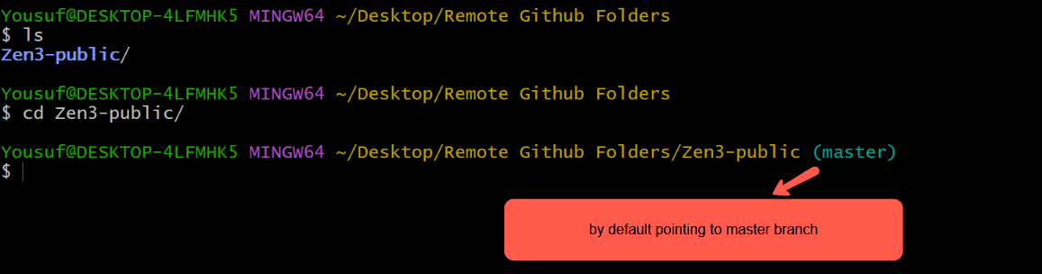

Execute the command ls –lrth to check the available files in Zen3-public repo   
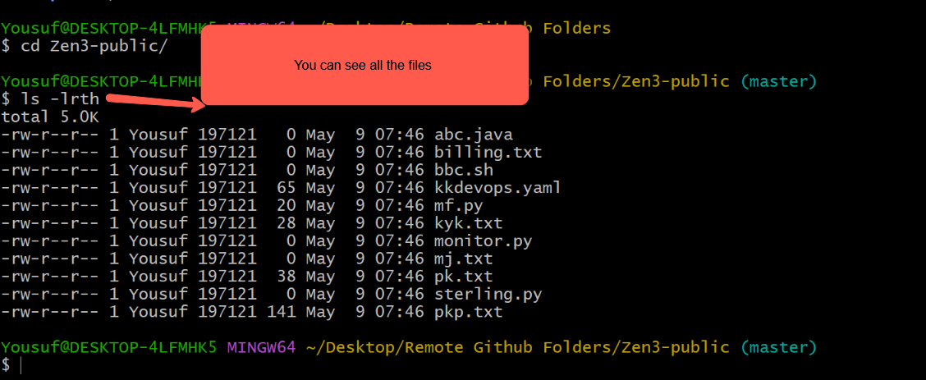

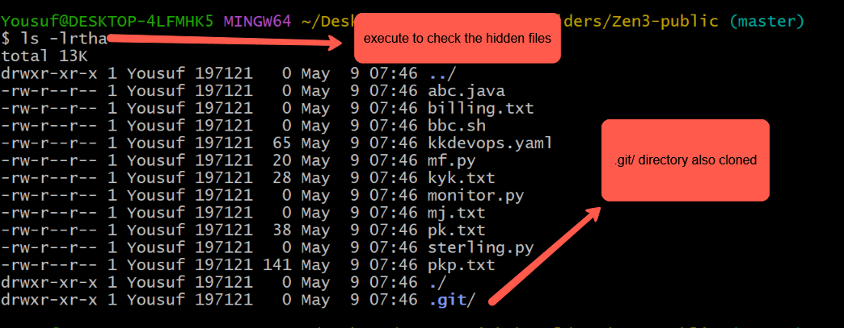

Execute the command ls to check the available files 

Lets create a configuration file as shown below **prod-deployment.yaml**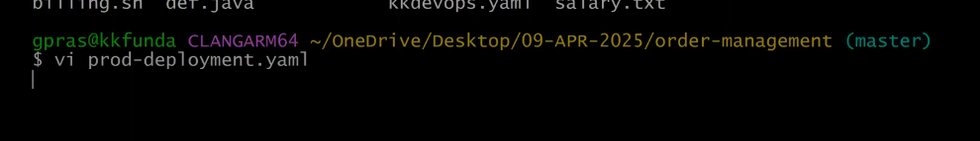

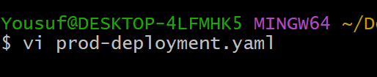

25:31 min

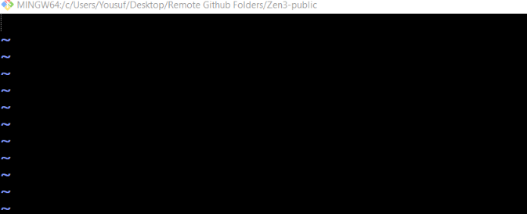

Insert some random data in to the newly created file for example  
apiVersion: apps/v1

kind: Deployment

metadata:

name: javawebapp

namespace: test-ns

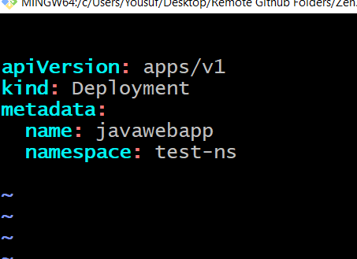

Configuration file **prod-deployment.yaml** is ready

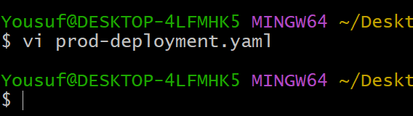

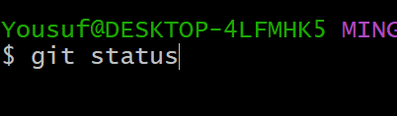

Execute the command **git add .**

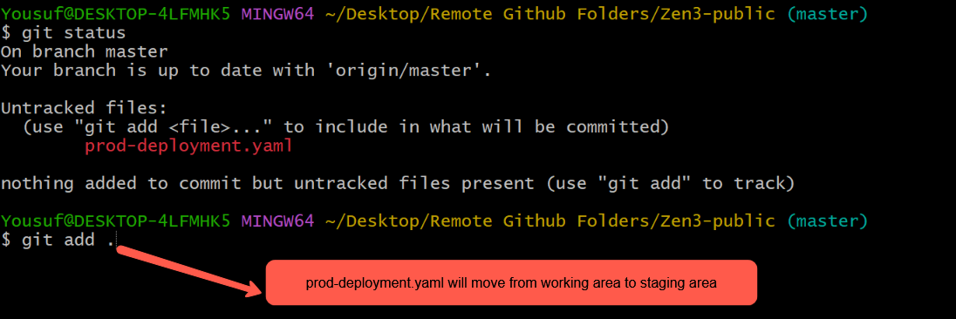

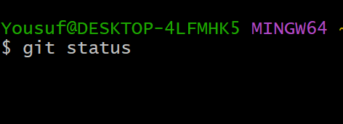

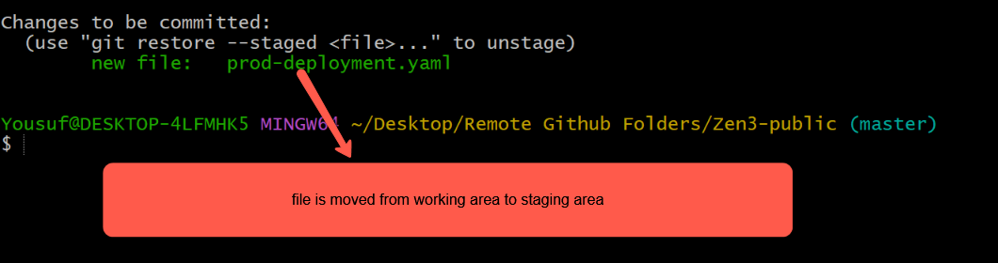

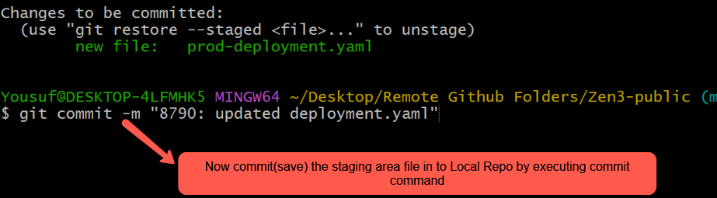

**To check last 4 recent commits we have to execute the command “git log -4 ”**

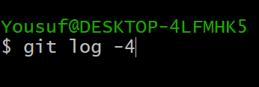

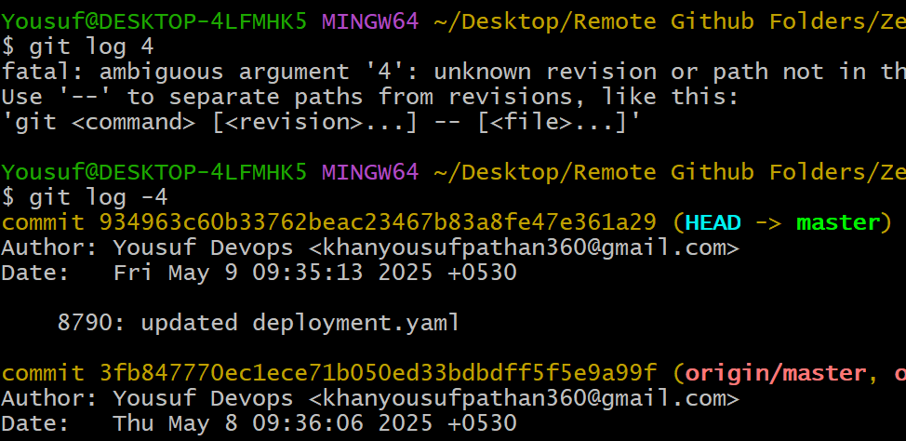

Now to push the master branch which includes the newly added prod-deployemnt.yaml file in to github repo  
first we have to identify remote repositories associated with your local Git repository, along with their URLs and purposes (fetch or push).

Execute the command git remote –v   
It displays the list of remote repositories associated with your local Git repository, along with their URLs and purposes (fetch or push).

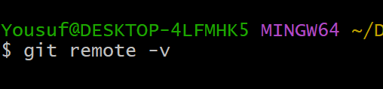

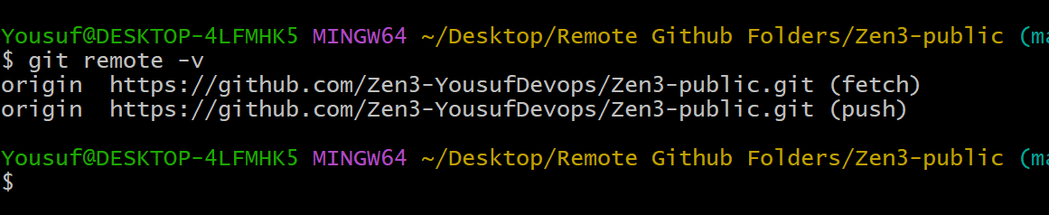

Next Execute the command git push origin master  
**Purpose:** It uploads your local master branch to the origin remote repository .

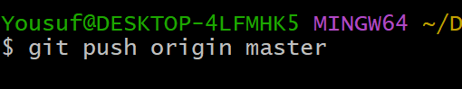

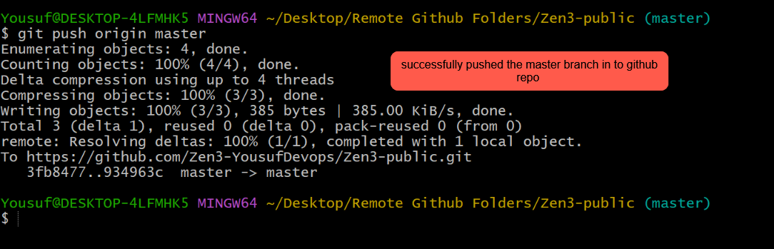

Now go and check the github repo and you will find newly added file prod-deployment.yaml file in the master branch of remote repo shown in the below image  
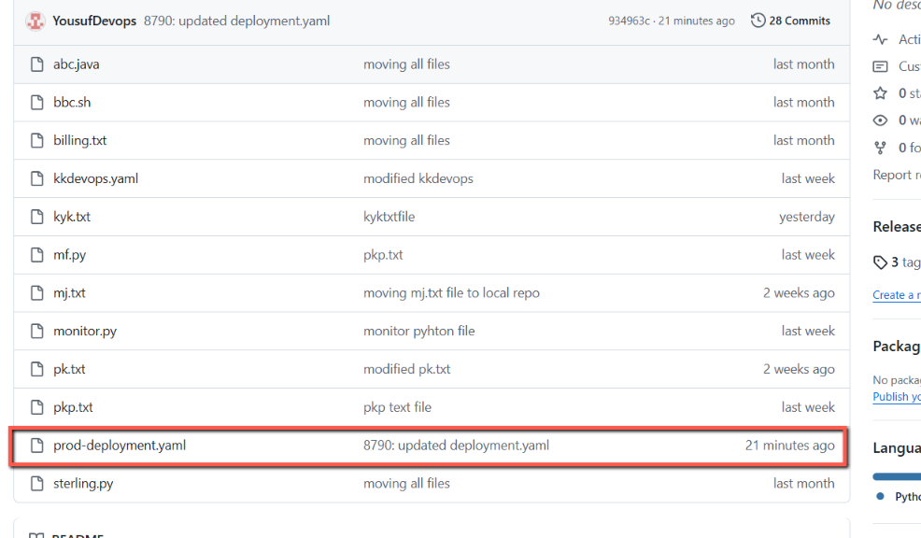

So in this way we have to copy the remote repository in to local computer folder using clone command and after performing editing activity slowly merge the code and the push the branch to GitHub repository.

Next Topic is very Important Topic  
Fast-Forward Merge concept :  
**Fast-forward merge is used to quickly combine branches when no changes were made on the main branch, keeping the commit history straight and clean.**

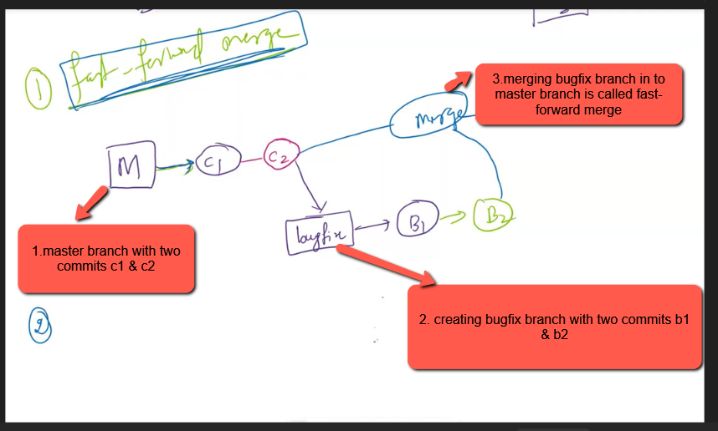

Example  
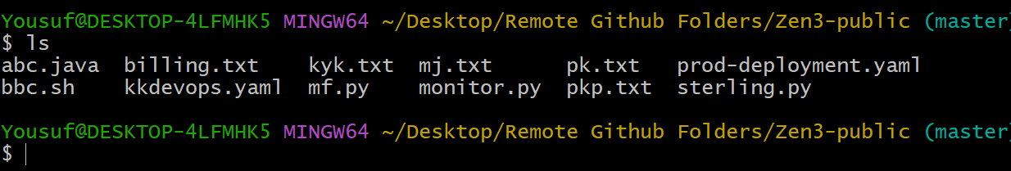

Update the file mj.txt and save it with commit ‘c1’

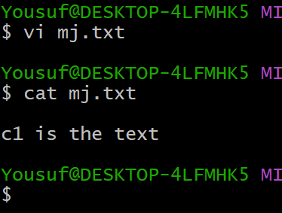

Now commit the file   
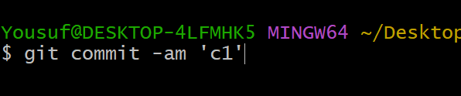

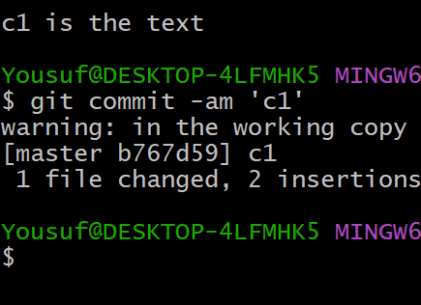

Now open the same file mj.txt and some data and save it with commit message ‘c2’

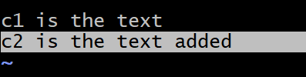

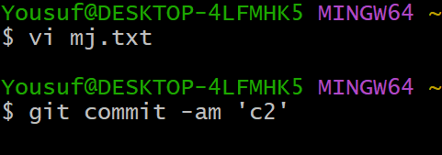

Now create another branch ‘bugfix’ from master branch and edit any file in the bugfix branch for muiple times and then try to merge the bugfix branch to master branch

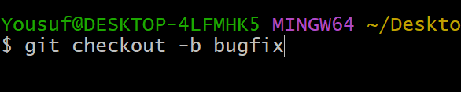

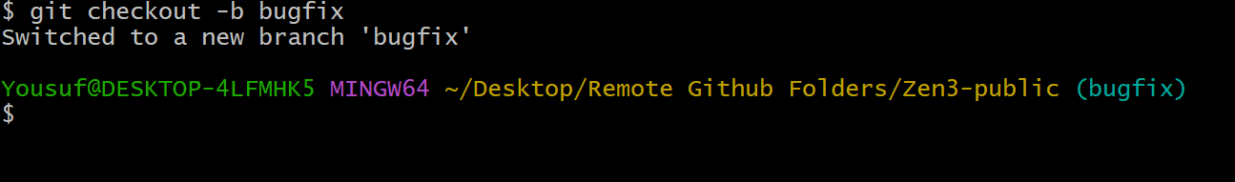

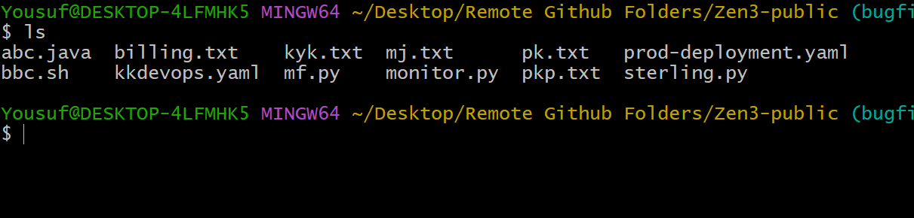

Create a new file   
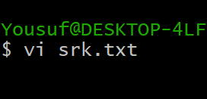

Write any message like below and save it and commit it with the message `s1’

Next edit the same file and add some data and save it with commit message ‘s2’

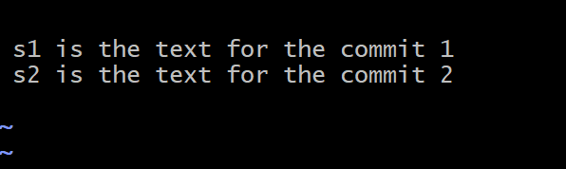

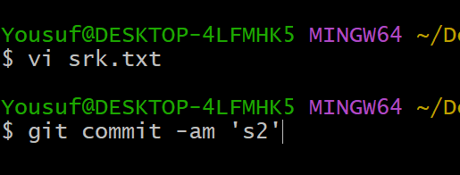

Now edit the same file srk.txt and add some data and commit it with the commit message ‘s3’

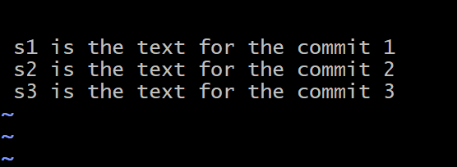

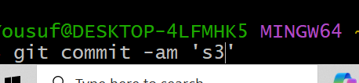

Now check the recently added commits by executing the command git log -6

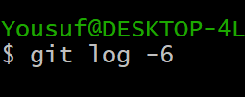

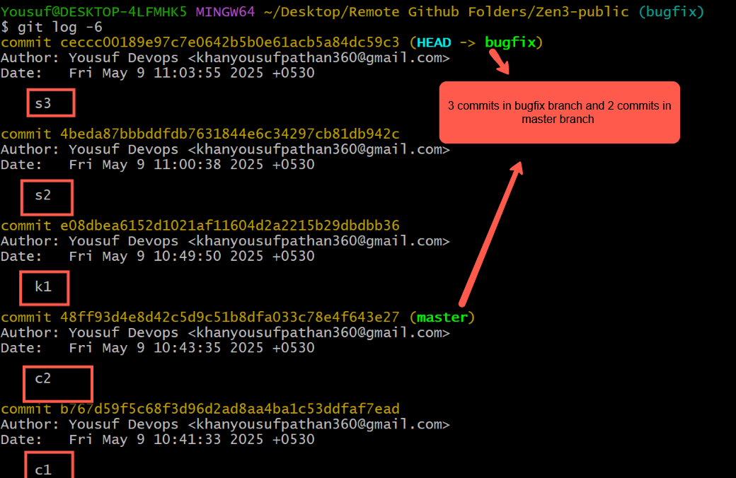

Next merge the bugfix branch in to master branch and you will see Fast-forward merge message after merging



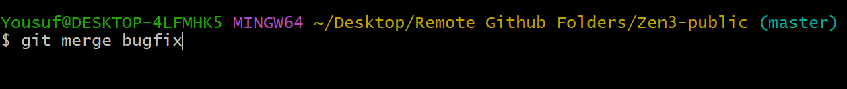

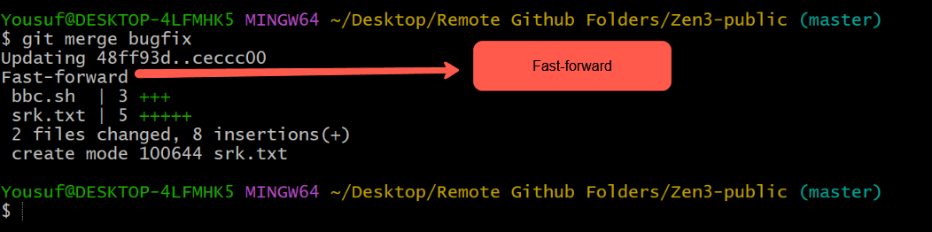

Execute git log -6 master and bugfix branch commits are merged as shown in the image

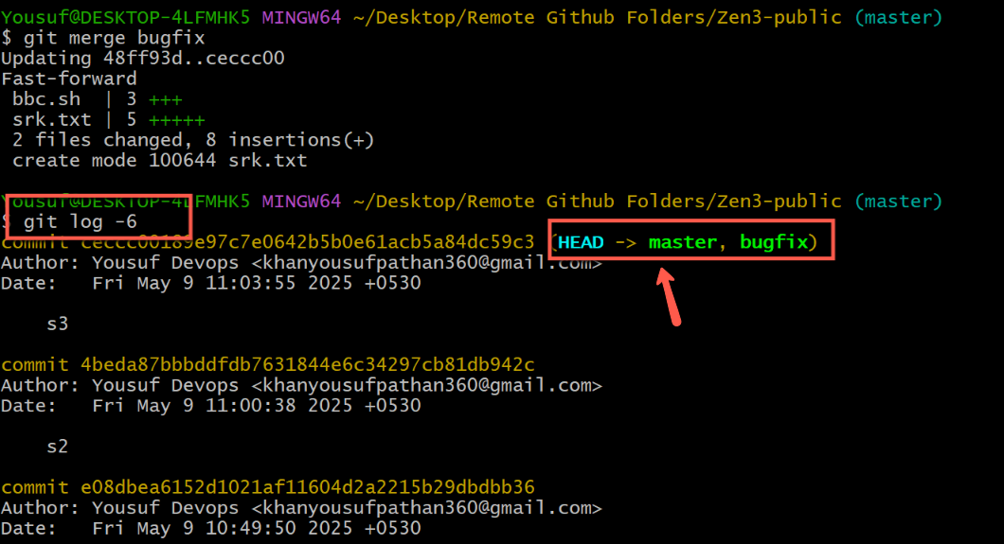

**Next concept is ort merge strategy concept**ORT (Optimized Recursive Tree) is used by Git to perform merges faster and more efficiently, especially in large repositories or complex merge scenarios. **check the video for better understanding this ort merge strategy concept time at 41:00 to 49:00**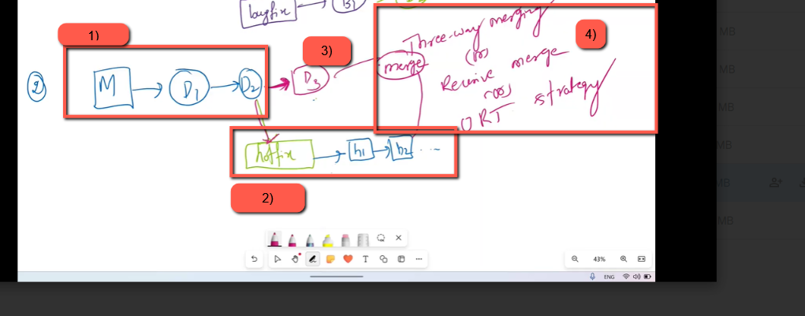

**In master branch create two commits d1 and d2**

**Then checkout to new branch hotfix and create two commits h1 and h2**

**And then checkout to master branch and create new commit d3  
Then try to merge the hotfix branch in to master branch after merging you will see ‘ort message’  
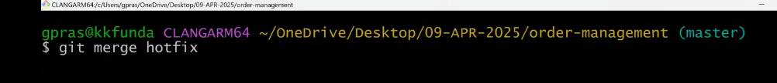**

**Next a new commit message file will be opened** **shown in the below image save it so save it**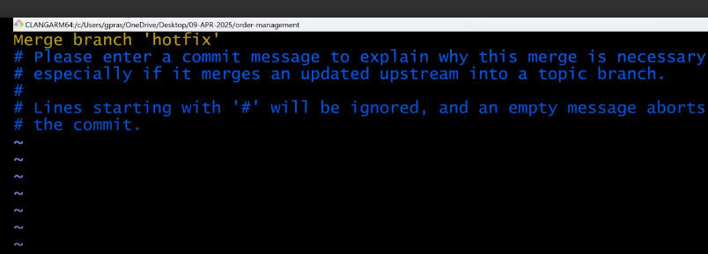

**You will see the message merge made by the ‘ort strategy’  
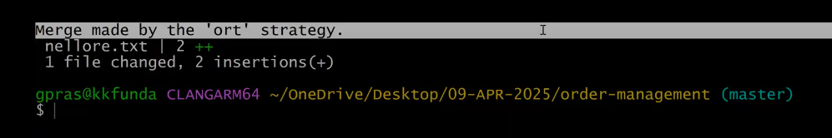**

**Git Rebase :** To maintain a clean and sequential commit history in the main branch, we use the git rebase command.

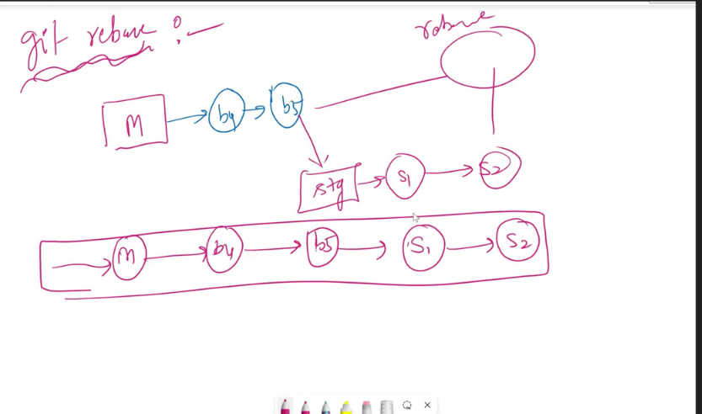

**Example :**

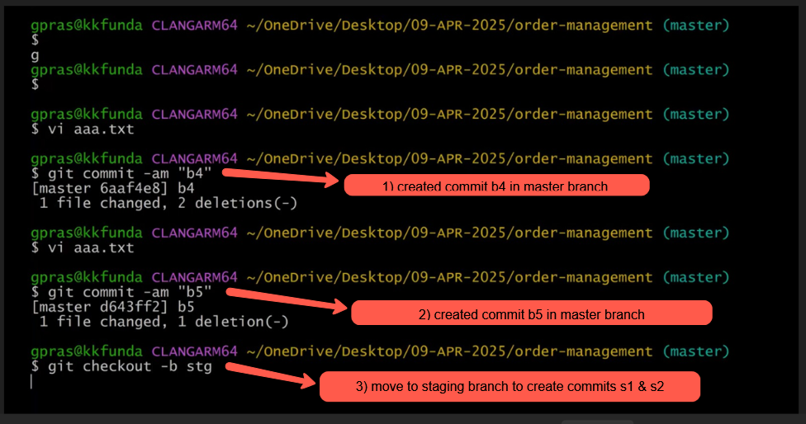

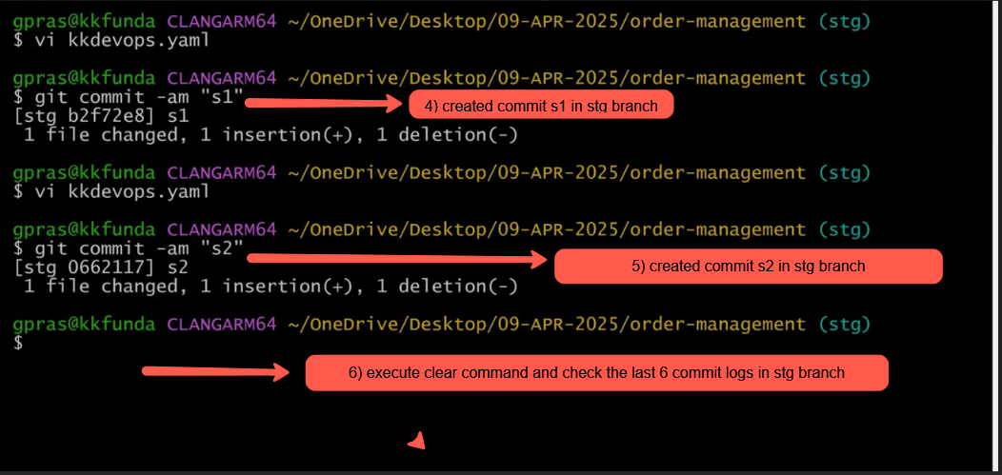



**Created total 4 commits two in master branch and two in stg branch as shown in the below image**

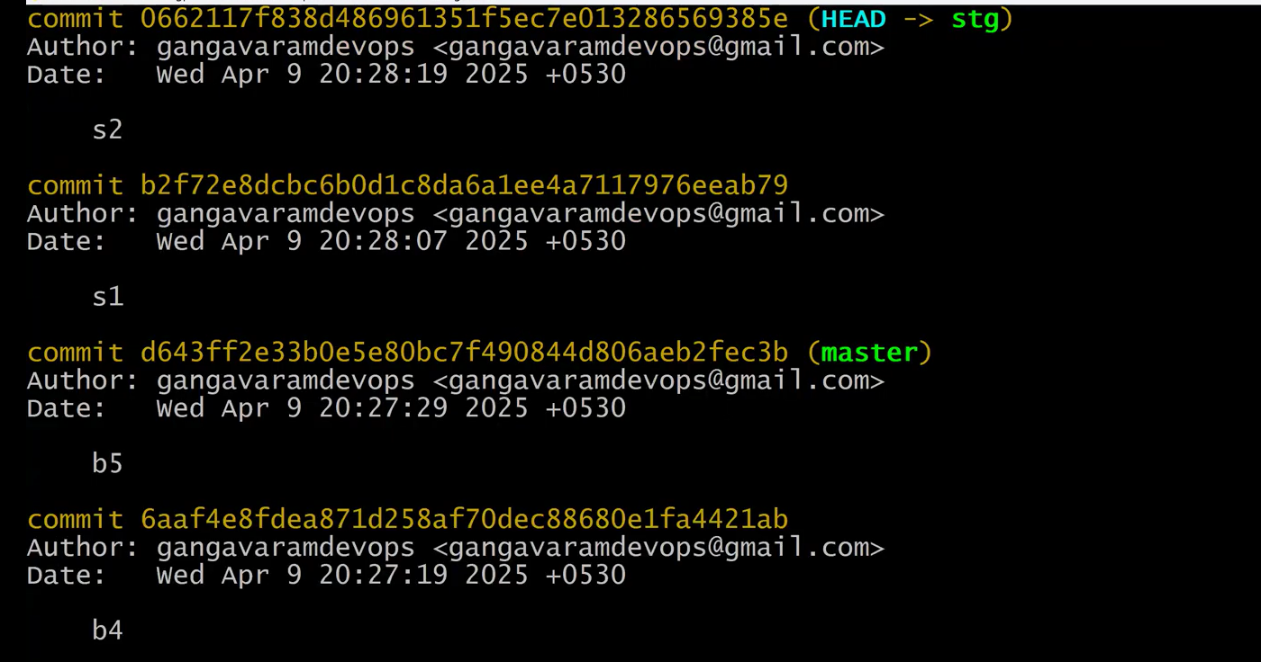

**Press q to quit from the above log commit screen**

**Next checkout to master branch and execute the log command git log -6**

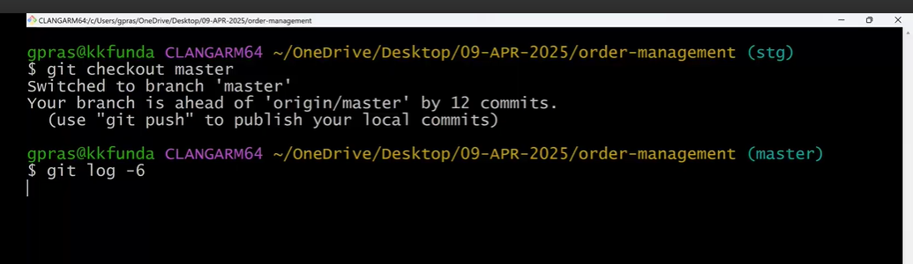

**In the below image you can see that cursor is in master branch and you can see there are multiple commits(b4,b5) in master branch but we can’t see the stg branch commits(s1,s2) here in master branch that because we haven’t merge the stg branch in to master branch yet.**

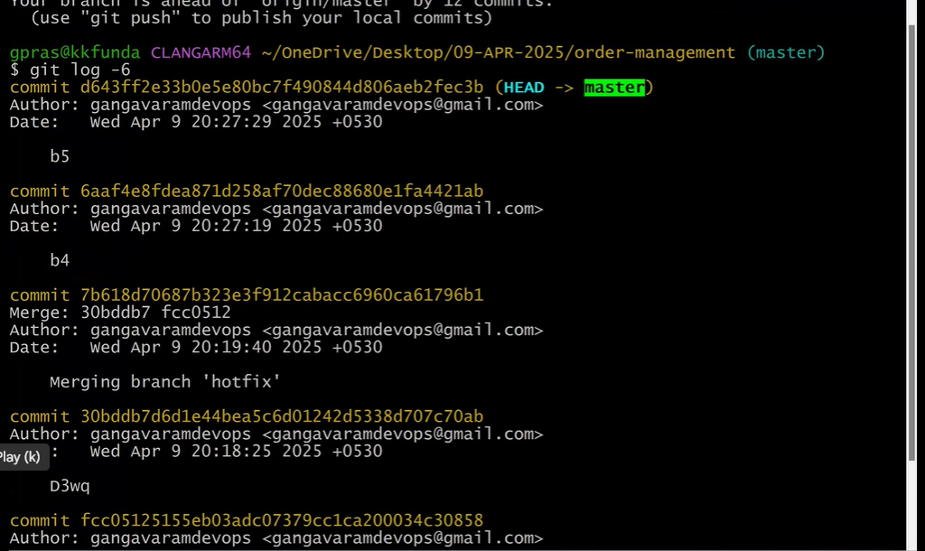

**Press q to quit the commit log screen**

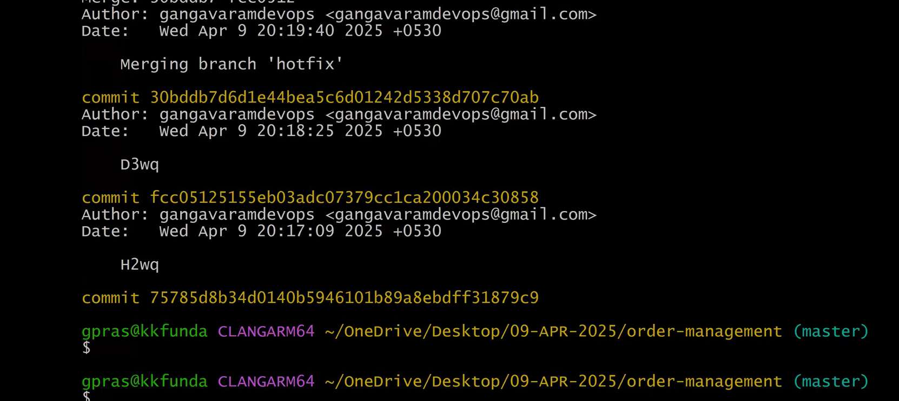

**Now use git rebase stg command to show the commit from stg branch in to master branch in sequential order**

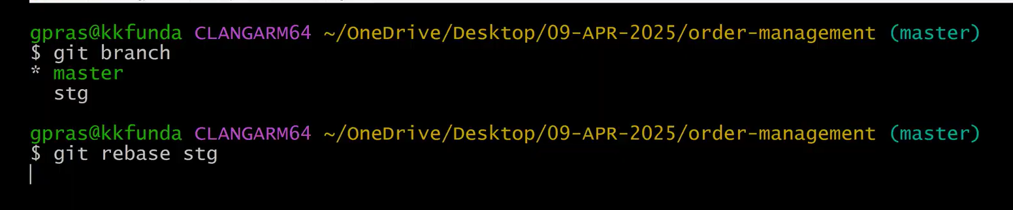



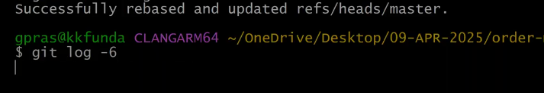

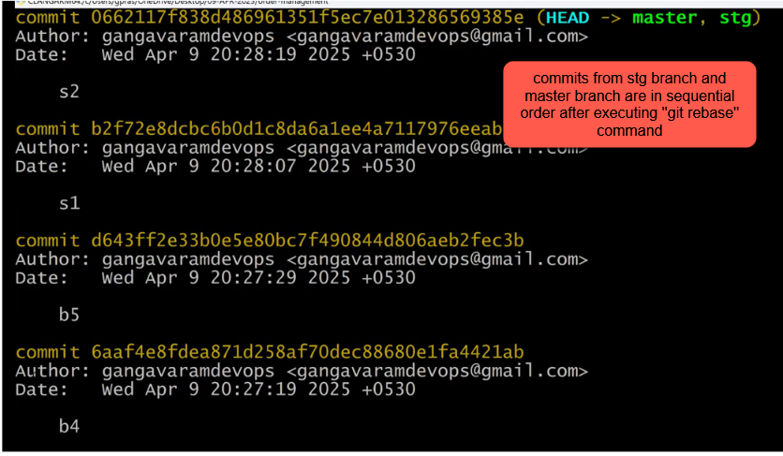

**------------------------------------------------------------------------------------------------------------------------------------------------------------------------------------------------------------------------------------------------------------------------------------------------------------------------------------------------------------------------------------------------------------------------------------------------------------------------------------------------------**

**Next command is “git cherry pick <commit-id> “ command :  
  
git cherry-pick** is used to **copy a specific commit** from one branch and **apply it to your current branch**.

Let’s see the below example  
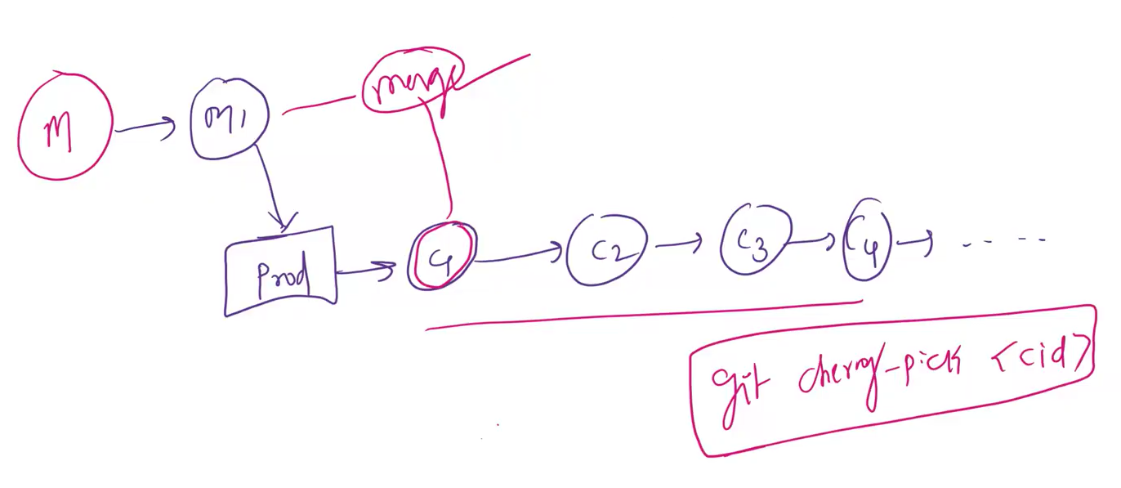

Get in to master branch and edit,update a file demo123.sh and commit it

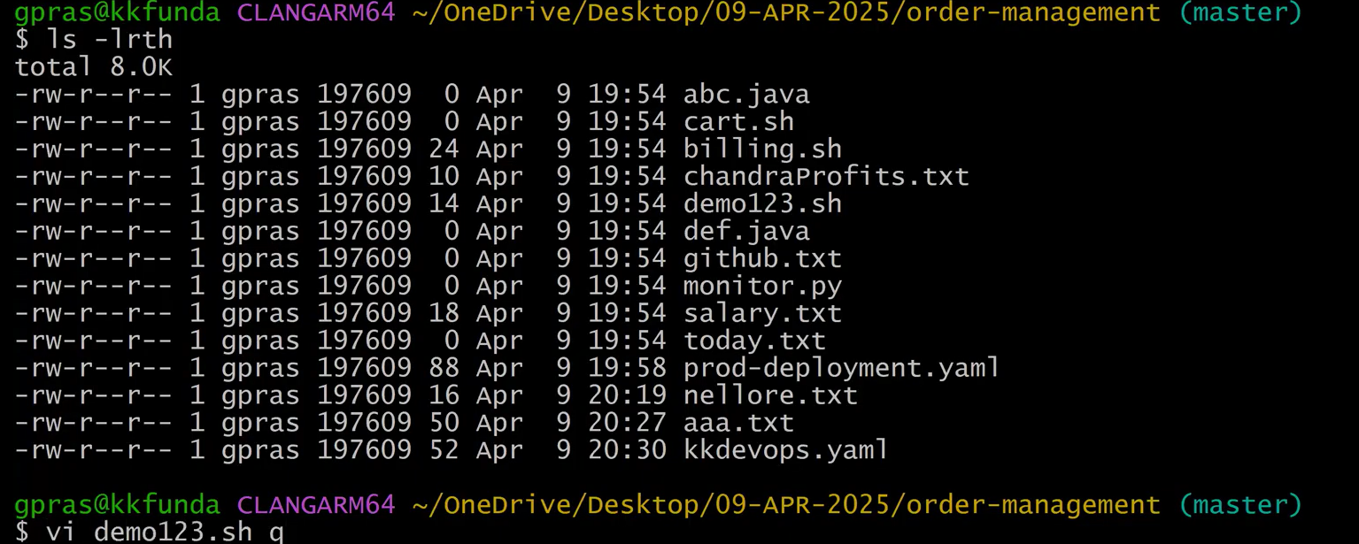

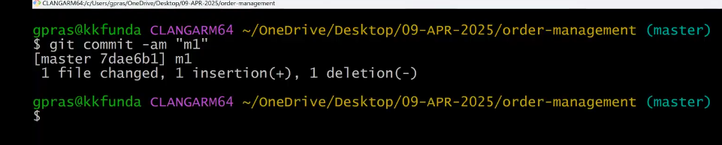

Git checkout to prod branch



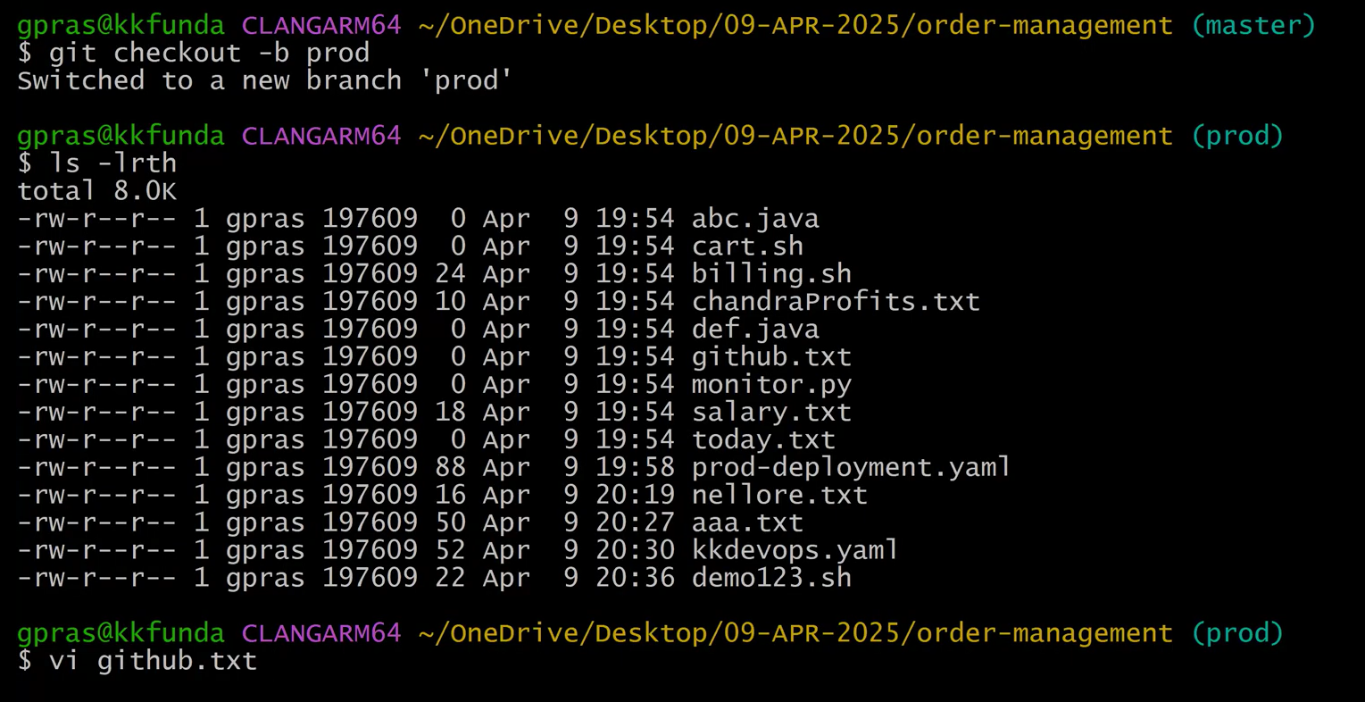

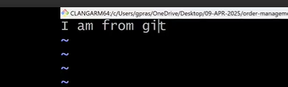

Commit the file github.txt with commit message shown in the below image

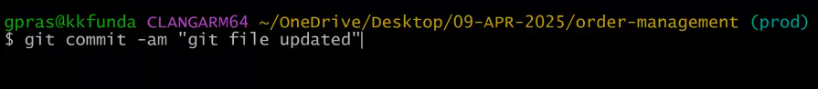

Now open the another file monitor.py ,edit it save it and commit it   
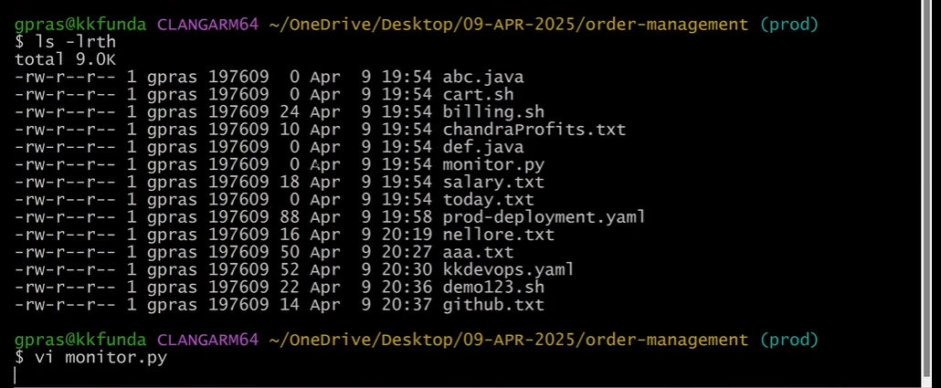

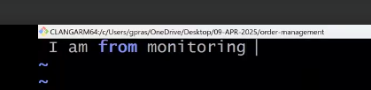

Next save it and commit it with a commit message  
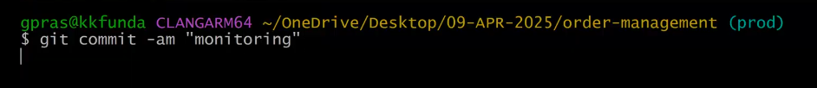

Next execute the command git log -4 to check the commits



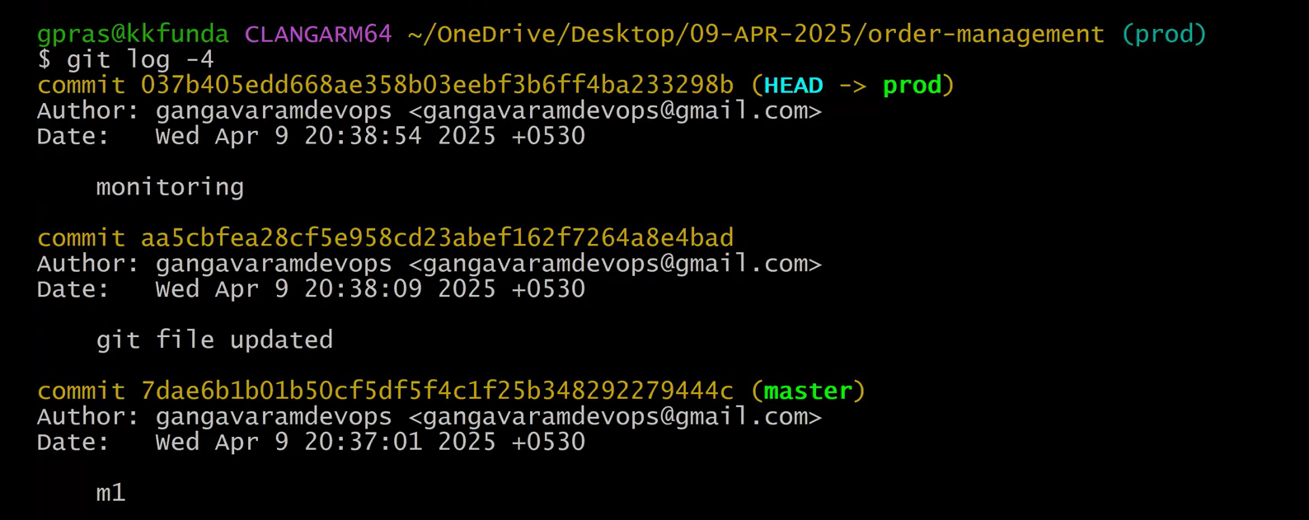

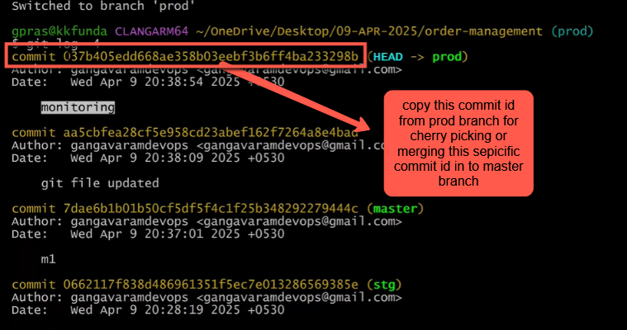

Let’s go to the master branch  
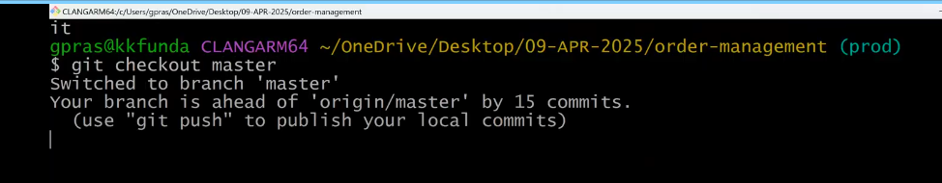

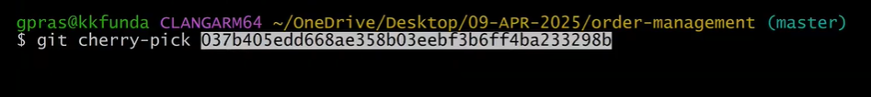

Successfully merge the file with comit id shown in the below image  
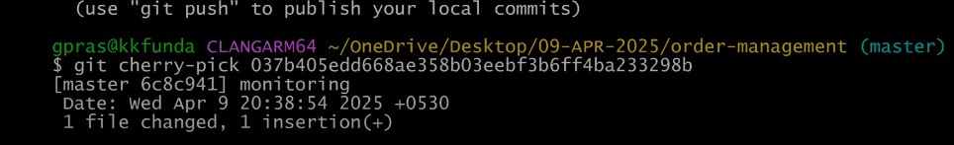

Next is very important topic asked many times in interview question time (1::10:00)

git fetch command :

The git fetch command is used to download the latest commits, branches, and tags from a remote repository, but without merging them into your current branch.

**📌 In Simple Terms:**

It **updates your local copy** of the remote repository (like origin) but **does not change your working files**.

There are three command used to fetch the updated or added code data from the remote repo(origin) in to our local folders local repo  
  
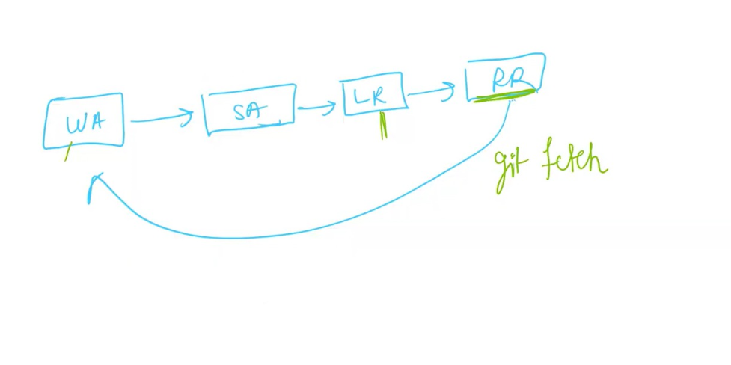

Assume two person working on same file one person has added some data in to that file monitor.java and push the local repo in to remote repo using git push orign command if the other want to get the updated code or the added data in the file he has to use the following commands to get the updated file data updated by other person in our local repo file

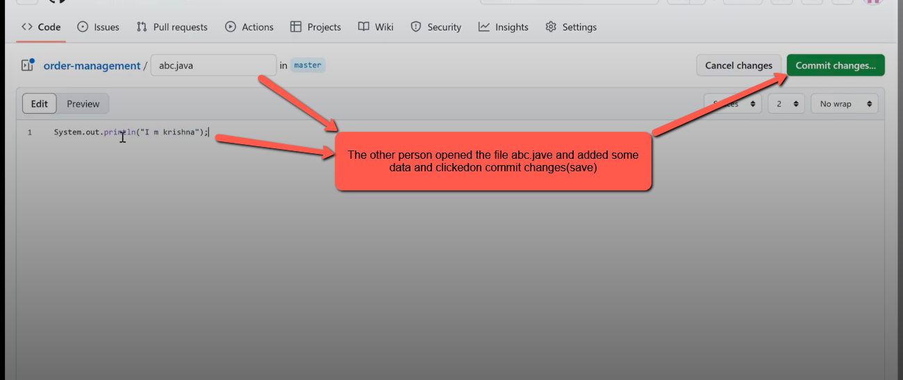

As you can see there is some data in Remote repo file abc.java shown in the above image and there is no data in Local Repo’s abc.java file shown in the below image .It means there is data inconsistency to resolve it   
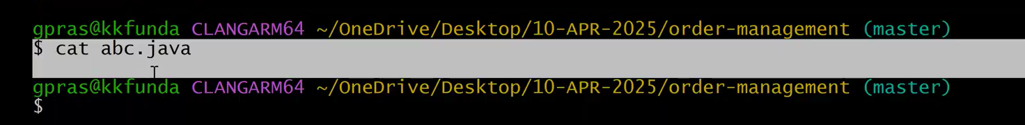

git fetch origin master ----> The updated data will be stored Local Repository but not added in our file abc.java . to see the updated code in the local repo we have to execute another command git merge origin/master

**✅ git fetch origin master**

* **What it does**: Downloads the latest changes from the master branch of the remote repository (origin) into your local .git directory.
* **Important**: It **does not** modify your working directory or your current local branch.
* It updates the reference origin/master, but not your actual master branch.

🧠 Think of it like: “Just **check what's new** on the server, don't apply it yet.”

**✅ git merge origin/master**

* **What it does**: Merges the changes from the **fetched** remote branch (origin/master) into your **current local branch** (usually master).
* You typically use this **after** git fetch.

🧠 Think of it like: “**Apply the updates** I fetched earlier into my current branch.”

git merge origin/master

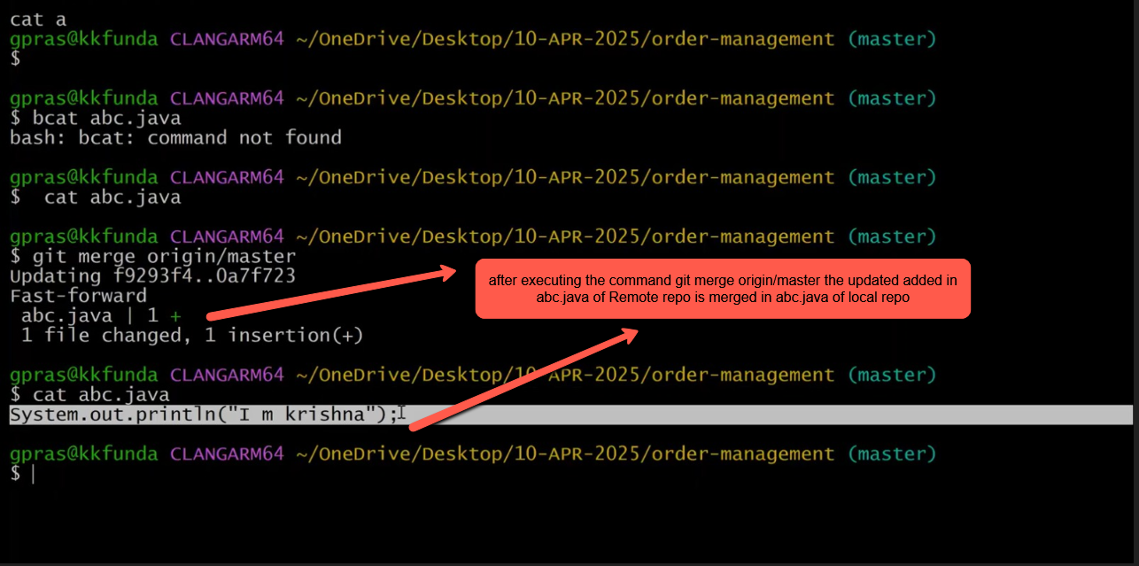

-----------------------------------------------------------------------------------------------------------------------------------------------

git pull   
  
Let’s assume the other user has again updated abc.java file added another line in the file abc.java and clicked on commit changes after adding the data as shown in the below image   
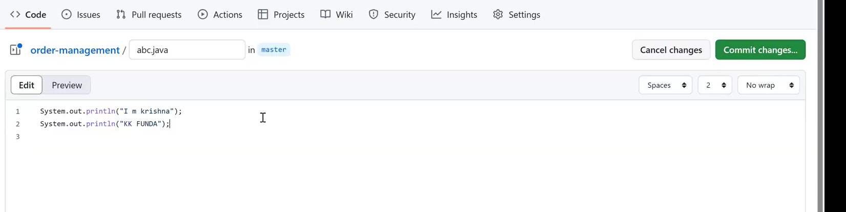

Now to get the updated code in to my abc.java local repository in my computer we have to execute the following command   
git pull origin master

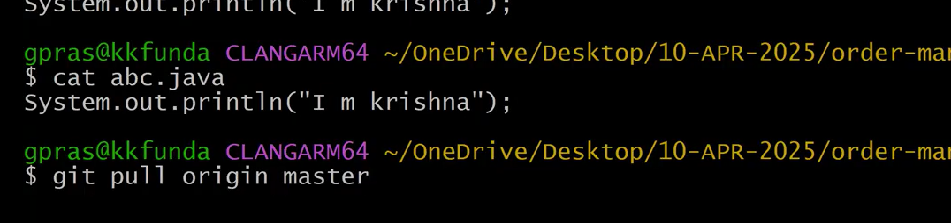

After executing the pull command the newly added line of code in abc.java can be seen in the below image

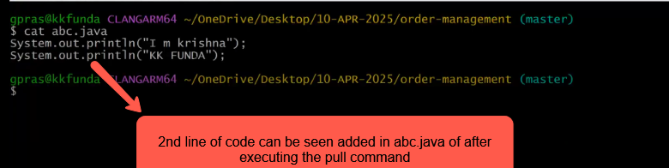

The class has ended and the Q&A starts from 1::28:00